GAMES FOR

CHILDREN

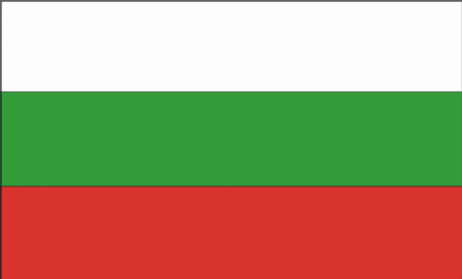  BULGARIA |  | “PROFESSOR DIMITAR DIMOV” SCHOOL  LOVECH
  POLAND |  | SZKOŁA PODSTAWOWA Z ODDZIAŁAMI INTEGRACYJNYMI NR21  IM. HENRYKA SIENKIEWICZA  GLIWICE
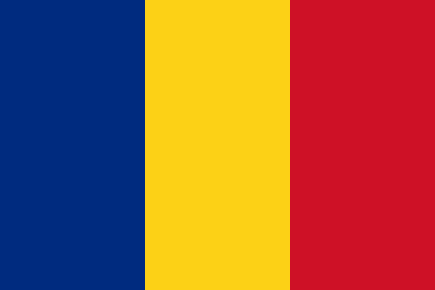  ROMANIA |  | ŞCOALA CU CLASELE I-VIII “MIHAI EMINESCU”  PLOIEŞTI
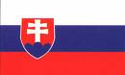  SLOVAKIA |  | ZÁKLADNÁ ŠKOLA S MATERSKOU ŠKOLOU BUNCIE  BUŠINCE
  THE UK |  | NCHS THE SCIENCE COLLEGE NEWCASTLE-UNDER-LYME
AUTHORS

CONTENTS PAGE
Introduction 4
The Bulgarian games 5
The Polish games 11
The Roamanian games 17
The Slovak games 23

Introduction

This booklet is a final product of the common work developed by the schools involved in the project “Beyond diSTances”(Şcoala cu clasele I-VIII “Mihai Eminescu”, in Ploieşti , Romania, “Professor Dimitar Dimov” School, in Lovech, Bulgaria, Szkoła Podstawowa z Oddziałami Integracyjnymi, nr 21 im. Henryka Sienkiewicza, in Gliwice, Poland, Základná škola s materskou školou Bušince, in Bušince, Slovakia, NCHS the Science College, in Newcastle-Under-Lyme, the UK), created within the framework of Lifelong Learning Program - Comenius.
With this assignment pupils presented their favourite games and plays which were used to organize a day of traditional games. This sort of activity aimed at making school a friendlier environment and values such as respect, fair-play, determination, team spirit were promoted by means of sport.

To discover more about our project, find us at www.scmeploiesti.lx.ro

Bulgaria

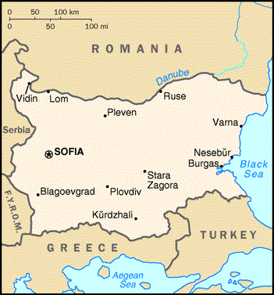

‘Guards of the King’s gate’

This is a game that children love very much. The guards are 2 children who think of a secret password. For example 2 flowers or 2 animals. Today the 2 girls decided to use 2 colours: red and blue.

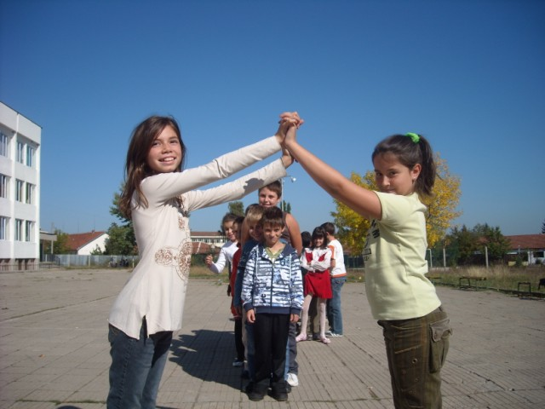

The game begins: the children sing this song: “Guards of the gate open it because the King is going to war, Open, Close, Leave only me!”

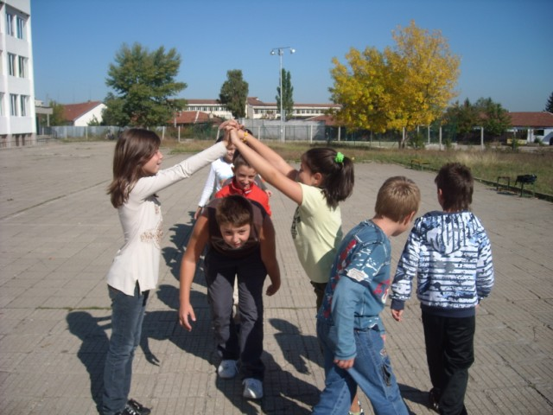

Spoon, Bowl, Saucepan (in Bulgarian these words rhyme).

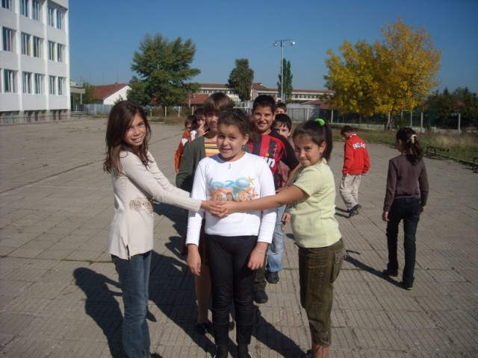

The first player is trapped, she has to choose between the 2 colours, after that the guards tell her whose team she will be in.

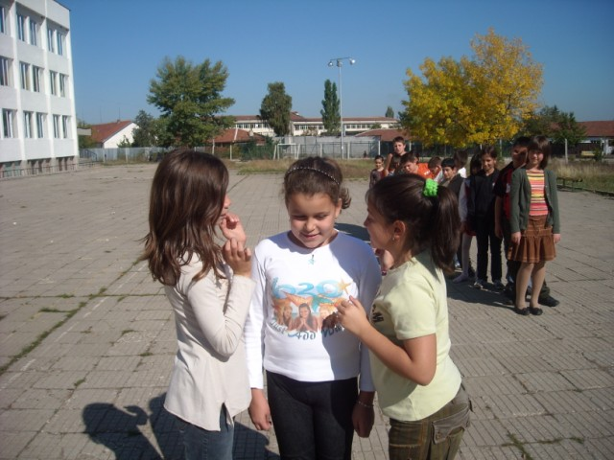
Next player, one more, one by one all are trapped.

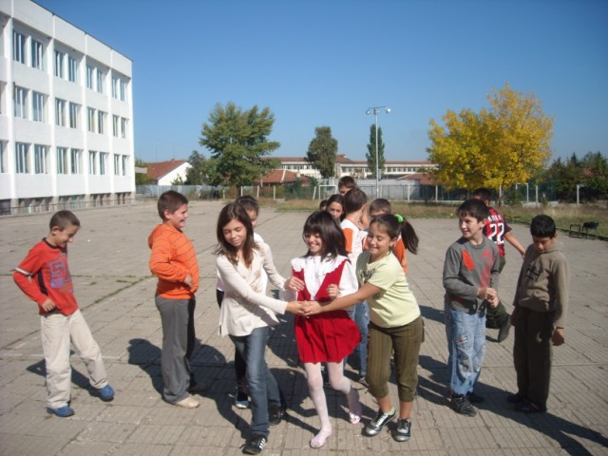

The 2 teams are ready. They will fight!

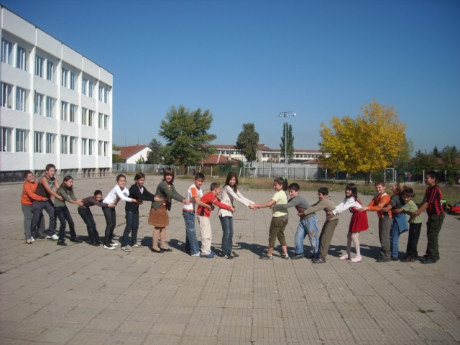

‘Drunk carrot. A ball game’

Children make a circle around the one who will be the Drunk carrot. They throw the ball to some child of the circle and the Drunk carrot tries to catch the ball, as soon as he catches it he is replaced by the one who throw the ball last. The funny name of the game comes from the fact that you may feel dizzy if you don’t have the chance to catch the ball quickly.

Hide-and-seek
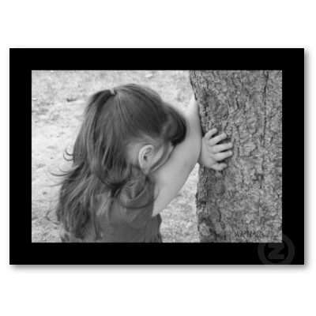

The simplest and most popular Bulgarian game is called “Zmichka” which means “close your eyes”. One of the children closes his/her eyes and begins to count, usually to 10 or 20 at a certain place. This place is very important for the game. During that time the other children have to hide somewhere around. As soon as the child sees someone quickly runs to the place he /she counted and says : “Pu for Ivan (for example)” . If Ivan manages to come to that place faster he has to say “Pu for me”. The sound “Pu” means “spit”. To spit on the place you came to, means that you won the game and you will not count with your eyes close. That child who comes last to the right place after the child who seeks has to close his/her eyes and count. This game is played during the summer when it is hot and there is no school, it is fun when there are a lot of participants.

‘Blind Granny’

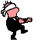
Blind Granny is the child who seeks the others. He or she seeks with a scarf on
the eyes. As soon as he or she catches someone he/she has to guess who the child
is. Usually the child tries to escape so the seeking Blind Granny has to hold him/her tight. If the personality of the caught child is guessed he /she becomes a Blind Granny. It is a summer game, too. You should wear old clothes, because it is possible to tear your T-shirt for example.

Fly, fly!
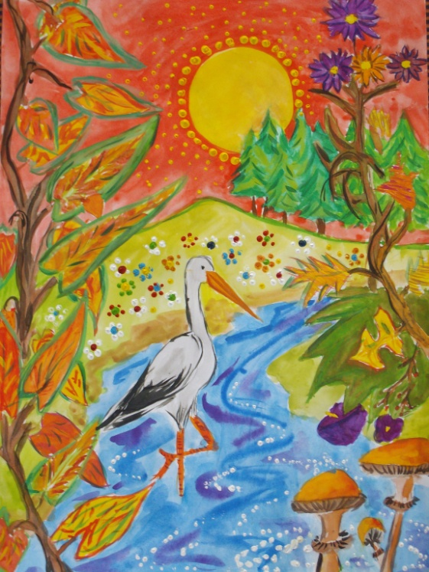

Fly, fly is the game for the youngest children -5, 6 or 7 years old. Everybody stands up. The teacher is in front of the students. She says “Fly, fly a swallow” (for example) and as the swallow is a bird the children wave their hands and arms like wings. “Fly, fly a stork”, the same gesture. At one point the teacher says “Fly, fly a house”(for example) as the house doesn’t fly the children mustn’t move, the ones who “fly” are out of the game. The winner is the last child.

Poland

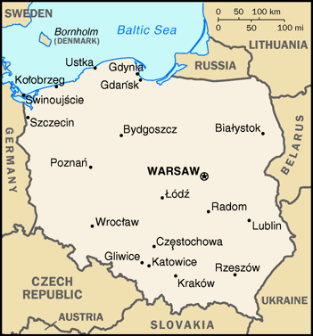

“The bricklayer’

The bricklayer is a game for children aged between 7-12. It can be played in the gym or in the schoolyard. The field used in this game is divided into two equal parts. In the middle there is a line where one player called’ the bricklayer’ stands. His/her task is to build a wall along the marked line. What ‘the bricklayer’ needs to accomplish his/her task is ‘the bricks’. ‘The bricks’ are other participants who stand on both sides of the line. Every player who is touched by ‘the bricklayer’ has to stand on the marked line. The more ‘bricks’ are caught the more difficult it is for the participants to move from one side to the other. The space left is getting smaller and smaller. The game lasts until the last player is caught.
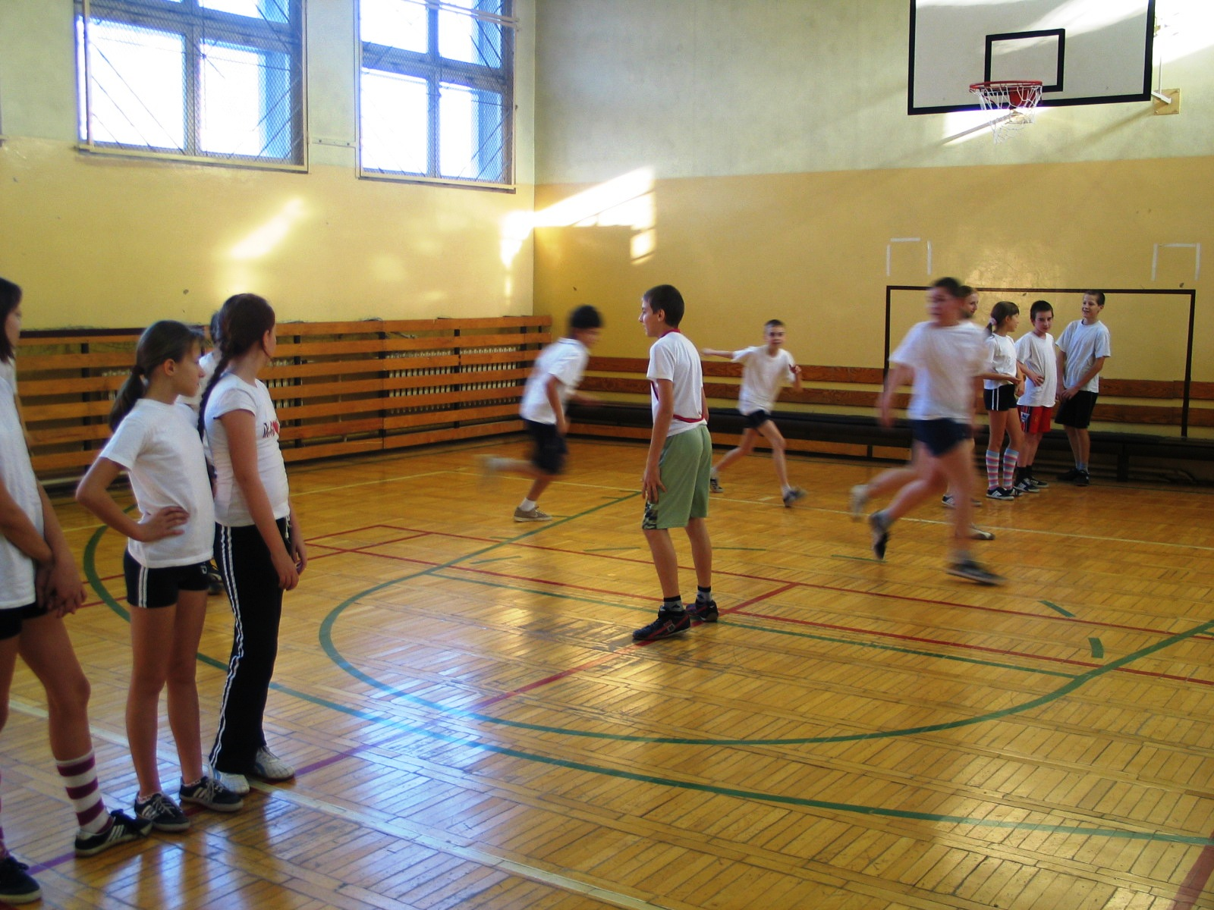
‘The Tag”

This game can be played by children aged between 7-12, inside or outside the school. In this game one player is ‘the tag’ and the others are ‘runners’. The task of ‘the tag’ is to run after the participants to catch them. The player who is caught becomes a new tag. The game starts again, but ‘the new tag’ chases ‘the runners’ with his/her hand put on the place touched by the previous tag.

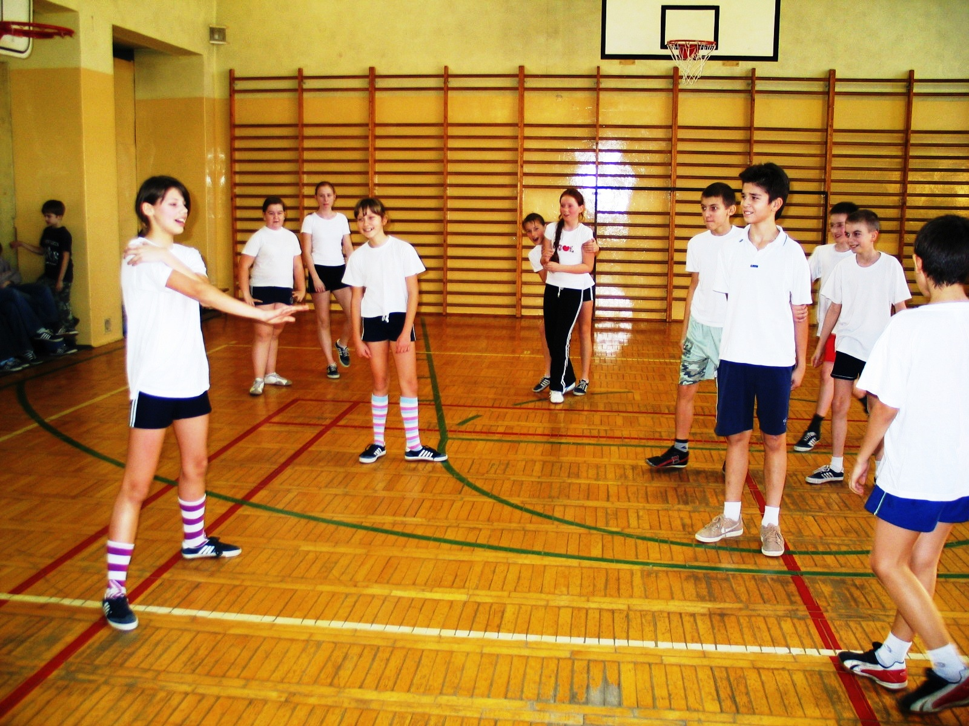

‘The Mice to the holes’
This game is for children aged between 5-10. It can be played inside or outside the school. The participants are divided into two groups: ‘the mice’ and ‘the holes’ (small circles). The task of ‘the mice’ is to run about. When the signal is given, the children have to find their own holes. Those mice who are left outside ‘the holes’, make the circles. This game can be repeated several times.

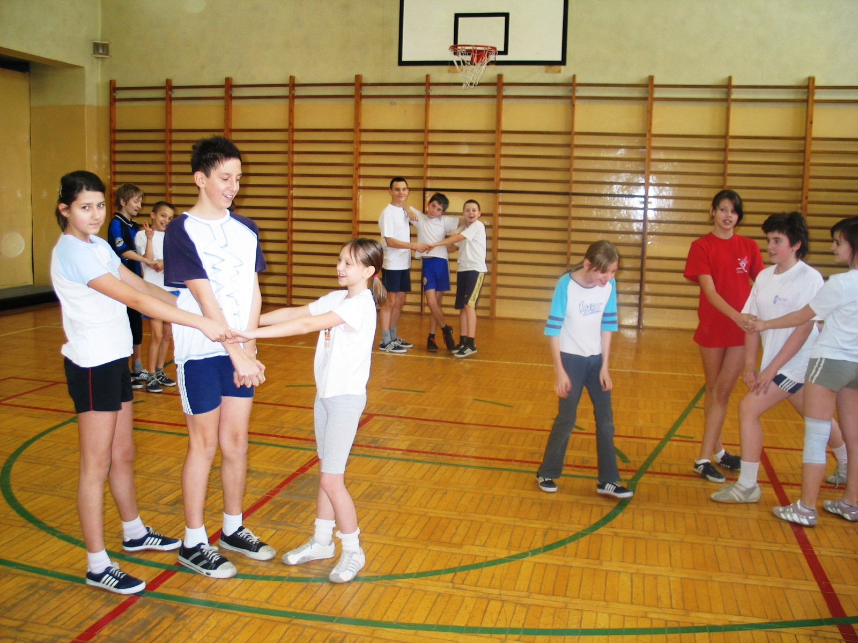

‘Blind man’s bluff ‘

This game is played by children aged between 5-12. It can be played both inside and outside the school. In this game a player whose eyes are covered with a piece of fabric tries to catch one of the participants, and then by touching, for instance his/her face, identifies him/her. If the given name is correct, they change their places and the game starts again.

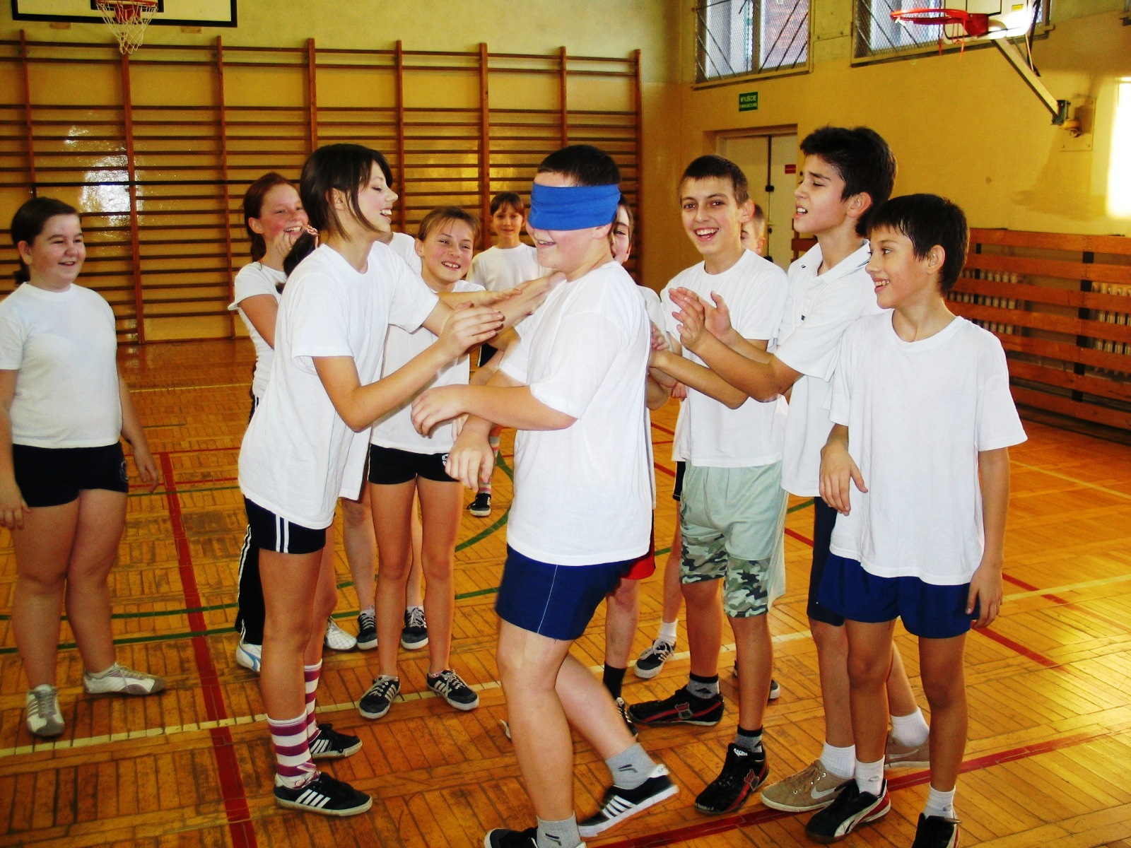

‘The mushroom’

This is a game for children aged between 7-12, played outsider the school. The materials needed to carry out this game are: little pebbles and a drawing of a big mushroom divided into seven parts.
The players have their own turns. Before the participant starts the game, she/he throws the pebble on one part of the mushroom. Then she/he jumps on every part of the drawing avoiding the chosen one. When the player gets to the last part, she/he turns around and jumps back . On her/his way back the participant has to pick up the pebble and jump on the chosen part before she/he finishes the game. If the player fails, she/he loses his/her turn.

Romania

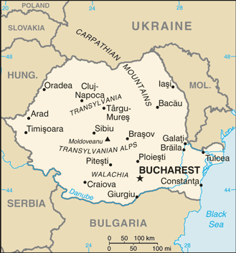

‘The stone bridge has been crushed’
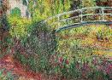

Two children choose a name which usually is the name of a precious stone or valuable thing. The other hold hands to one another and pass under the "bridge" made by the hands of the children standing in pairs. Everybody is singing
the following song:
"The stone bridge has been crushed,
The water came and took it away.
We will build another one down the river,
A more lasting and beautiful one."
When the song is ready one of the children is "caught" in the very moment he passes under the bridge. The caught child has to choose between the two names and he will then follow the one he has chosen. The game continues until the last child has been "caught“. The last two children who were the bridge hold hands and the others behind them, according to the name they have chosen, start to pull in opposite directions, until the stronger party wins.

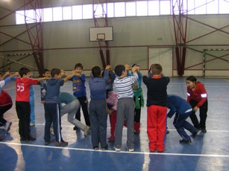

‘Country, country, we want soldiers’
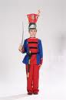

There are two teams playing the game. The one who starts the game says:
"Country, country, we want soldiers!" The other one replies:
"Whom?" One child is chosen to be a "soldier“ and he has to “break” the wall made by the other team’s members who are holding their hands as strong as they can . If he succeeds, he goes to the adverse team, if not, he remains with his team. The game continues until one of the two teams gathers more soldiers.

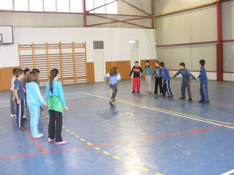

‘Ducks and hunters’

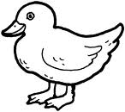

There are two “hunters” and a bunch of ducks. The hunters try to “shoot” the ducks with a ball. The one who is hit by the ball has to leave the game.
At the beginning of the game, children establish the rules, which means that the ducks may have multiple lives or only one.The game ends after the last duck is shot.

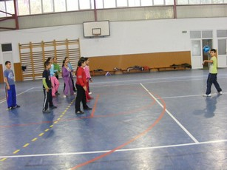

‘Tag running’

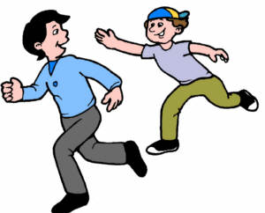

A playing area is chosen, then the children gather in a circle. They use a counting rhyme to decide who is going to be “Leapşa” (“it").
The last one counted out will stand at a distance while the group lines up. When the signal is given, “leapşa” will chase the others and try to touch one of them with the hand. When this happens, the person touched becomes “it”.
A variant of the game is to eliminate everyone who gets touched, until there is no one left.Other types include “Perching leapşa” (in which you are safe if you perch on a box, bench, tree stump etc) and “Lying leapşa” (in which you quickly tell an obvious lie not to be touched).

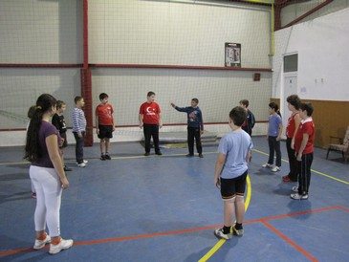

‘Hopscotch’

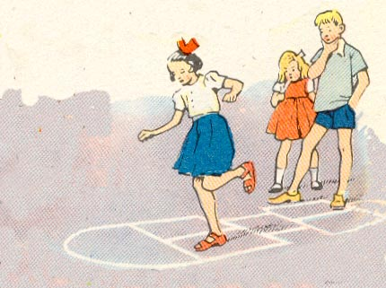

First of all, children draw a course on the ground, usually
with chalk. Then they decide who the first player is by a numbering rhyme. A marker is chosen, usually a flat stone. The player stands in front of the first square (1) and tosses the stone without touching any lines. Then you hop on one foot over the square (2) with the stone and all through the course (3).You can put both feet down on side by side squares (4) and on the final circle. Here you turn around and hop again to the first square to pick up the stone (5). If you lose balance or step on a line, your turn ends. The winner is the first who hops the course for each square.

- 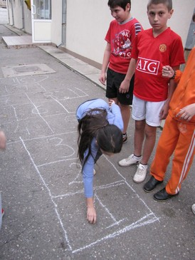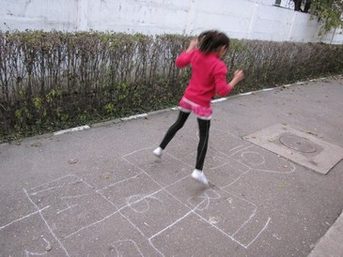

Another more difficult variant involves pushing the stone with your foot while hopping through the course, again without touching the lines.

Slovakia

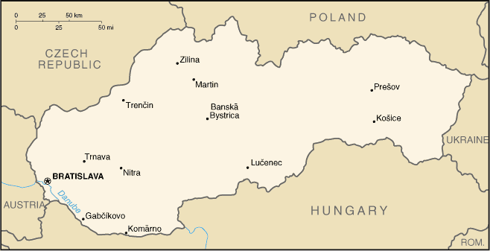

‚A little sparrow is jumping‘

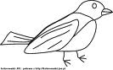

Children are standing in a circle. One of the children is standing in the middle of the circle as „a sparrow“. He/she is jumping like a sparrow with hands having as wings. The children are going round the sparrow in a circle holding each other hands and singing. The children in the circle stop and clap their hands until the song is not finished. The sparrow chooses another child who is going to be the next sparrow.

‚We have caught a cock‘
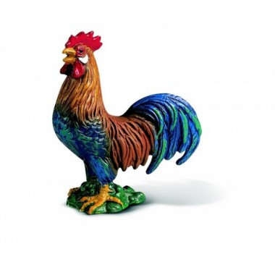
Children are walking in a circle. One child is standing in the middle of the circle like „a cock“. Then the children stop and say: „Sing cock, sing!“The cock cocks – a – doodle – doo. After that the cock tries to escape from the circle while the children are standing holding each other hands and moving up and down.
When the cock escapes he/she chooses another child who is going to be the next cock.

‚A goat is in the garden‘
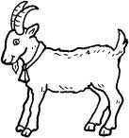

Children are walking in a circle holding each other hands and singing a song.
One of the children is standing in the middle of the circle /garden/ as „a goat“. One of the children is standing outside the circle as „a farmer“. The children in the circle stop singing and say to the goat: „What are you doing in the garden?“. The goat answers them: „I am looking for a cabbage“. Then the farmer asks the goat: „ Did you dig?“. The goat replies: „I am digging at the moment.“ /and the goat shows it with his/her feet/. Then the farmer asks the goat: „Did you water the plants?“ The goat answers: „I am watering them now.“ /shows it with his/her hands/. Then the farmer tells the goat: „ When I will go in, you will go out.“/the farmer tries to catch the goat running round the circle/.
When the farmer catches the goat other two children are going to play the part of the goat and the farmer.

‚A new road is leading‘
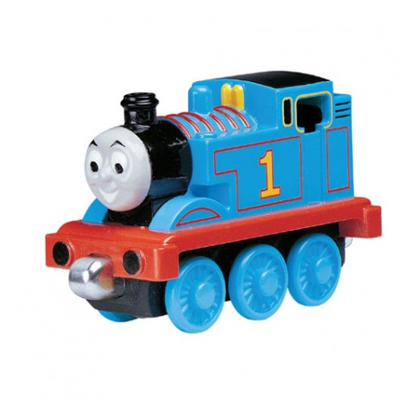
Children are walking together like a train holding each other shoulders.They are singing and walking and showing the things they are singing about. /clean hands, washing the face, combing the hair, dancing, travelling/.

‚A rabbit‘
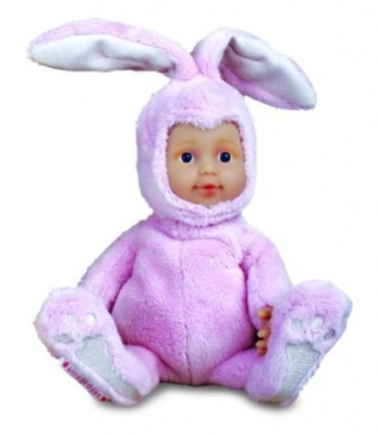

Children are walking in a circle. One of the children is crouching in the middle of the circle and sleeping. The children are singing „hopi – hop“ and clapping with their hands. Then the rappit is jumping in the middle of the circle. After that another child is going to be the rabbit.

‚Pesek goes round‘
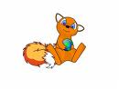
Children are sitting in a circle. One of the children is Pešek and he/she is going round the circle with a handkerchief in his/her hand and singing.
Pešek is putting the handkerchief on the head of one of the children from the circle and then he/she tries to catch Pešek. Pešek tries to sit on the place of his/her pursuer. When Pešek is successful the other child, the pursuer, is going to be Pešek.

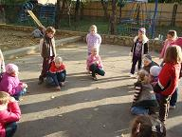
‚I have fallen in a well‘

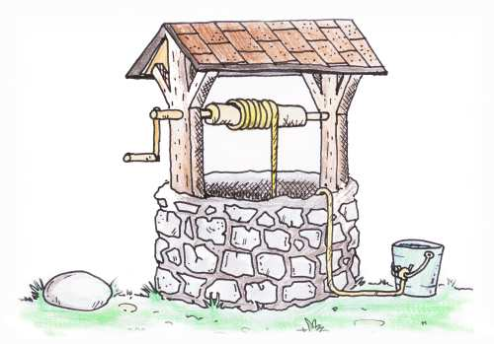

Children are sitting in a circle. One of the children is sitting in the middle of the circle /well/ and saying: „I have fallen in a well“. The children ask: „Who should pull you out?“ the child in the well answers: „The one who is sitting and holding his ... /chooses a part of the body/. The children in the circle are holding the part of the body the child from the well told them. The child from the well chooses a child who is going to pull him/her out from the well and stays in it.

